Name: Puna Poudel

Assignment: Exercise 2.3 (Data Models)

Due Date: 09/06/2024

Professor: Chandra

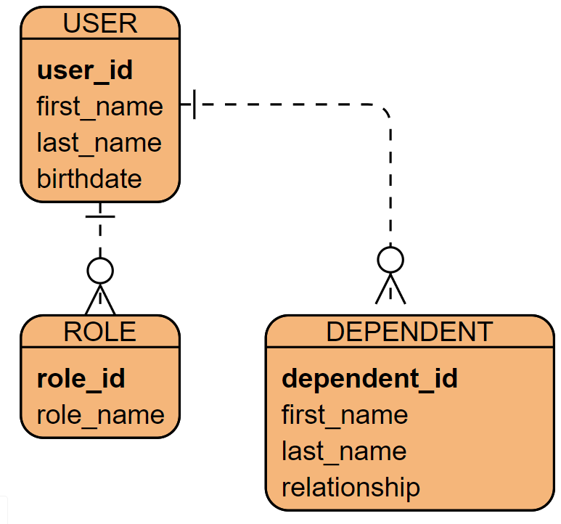

Here is the diagram of no Sql Data structure:

{

"user_id": "1",

"first_name": "Puna",

"last_name": "Poudel",

"birthdate": "1980-01-01",

"roles": [

{

"role_id": "1",

"role_name": "Admin"

},

{

"role_id": "2",

"role_name": "User"

}

],

"dependents": [

{

"dependent_id": "1",

"first_name": "Pari",

"last_name": "Poudel",

"relationship": "Daughter"

},

{

"dependent_id": "2",

"first_name": "Prakash",

"last_name": "Poudel",

"relationship": "Son"

}

]

}